Spatial Analysis of Live Facial Recognition Deployments in London, 2025

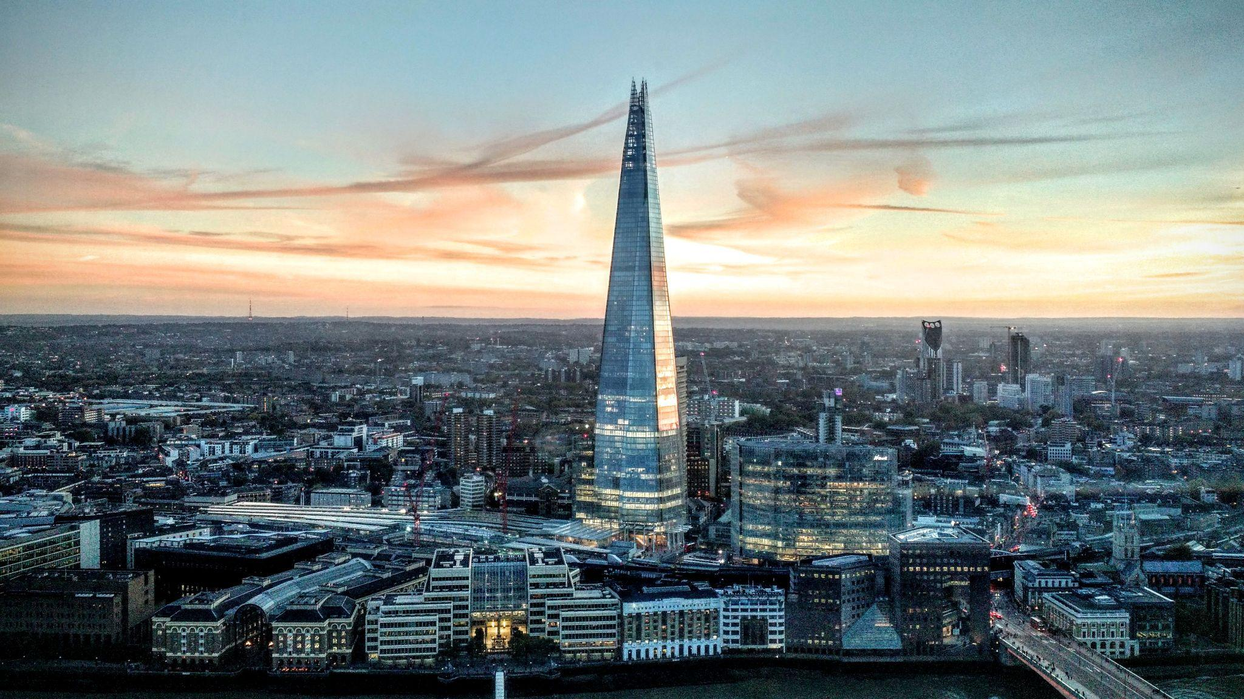

GIS-centred analysis of live facial recognition deployments by the Metropolitan Police, set against stop & search statistics and metrics of socio-economic deprivation.

## 

## Barney Solly

### Project repository: [github.com/barneysolly/london-lfr](http://github.com/barneysolly/london-lfr)

**License:** This report is licensed under a Creative Commons Attribution 4.0 International License (CC BY 4.0).

23/01/2026

## Contents

**Executive Summary 3**

**Introduction 4**

**Research Question 5**

**Data 5**

**Methods 6**

**Limitations and Scope 7**

**Findings 8**

**Figures and Tables 9**

**Interpretations 13**

**Policy Implications & Conclusion 14**

**Bibliography 1****6**

## 

## 

## 

## 

## 

## Executive Summary

This report analyses the geographic distribution of live facial recognition (LFR) deployments by the Metropolitan Police in 2025. It uses Police and Home Office data to map LFR deployments against stop & search levels and deprivation measured by the Index of Multiple Deprivation (IMD). The granularity of the mapping and analysis is at the Lower Level Super Output Area (LSOA) level.

This analysis is important because current LFR use is contentious, and there is a lack of specific regulations overseeing its deployment.[1] Understanding how deployment locations co-locate with other contextual factors allows for systemic assessments of the risks associated with current deployment practices.

The report includes three maps and an analysis of the data used to generate the maps. The first map (Figure 1) tracks 2025 LFR deployments against 2025 stop & search data. The second map (Figure 2) tracks the change in stop & search levels between 2023 and 2025 against 2025 LFR deployments. The third map (Figure 3) charts LFR deployments against 2019 IMD data for each LSOA.

Results show a positive correlation between the number of LFR deployments and levels of stop & search activity and deprivation. The report interprets deployments as clustered in areas experiencing high stop & search activity and ranking amongst England’s most deprived.

The report concludes that the concentration of LFR deployments in these areas may reflect disproportionate policing methods. It argues that the concentrated and cumulative impact of high LFR and stop & search activity in deprived communities leads to an outsized surveillance burden. The report points to this being a “substantially different experience of policing by a specific group”, which is a definition of disproportionality provided by His Majesty’s Inspectorate of Constabulary and Fire & Rescue Services in 2021.[2]

## 

## Introduction

Live Facial Recognition (LFR) is used to scan the faces of the public and match against a temporary “watchlist” of individuals that are of interest to the police.[3] The technology is built on AI algorithms that translate identifying features into a numerical “biometric template”, which is then used to calculate the likelihood that two facial images belong to the same person.[4]

Trials of the technology began in 2016. As of November 2025, over 13 police forces have trialled or deployed LFR in some way, a number which has more than doubled in a year.[5] There is tension between those who point towards its proven ability to catch dangerous criminals, and others who argue that the technology poses a threat to “rights to privacy, freedom of expression, and freedom of assembly.”[6]

Statistics released in January 2026 have pointed towards London’s murder rate reaching an 11-year low. Met Police Commissioner Sir Mark Rowley cited LFR as a factor in the fall in homicides.[7] Other factors, such as a reduction in the use of stop & search, have also been identified as coinciding with the drop in murder rates.[8]

In the same month as these murder statistics were released, the High Court is due to hear a case brought against the Metropolitan Police by Shaun Thompson and Big Brother Watch. After being misidentified by LFR in 2025, Mr Thompson described the experience as "intimidating" and "aggressive" and as “Stop and Search on Steroids.”[9]

Connections to stop & search are the report's first base for investigation. A drop in stop & search has coincided with a fall in homicide and a rise in LFR use. Yet those experiencing LFR failures have equated the two tactics. Furthermore, both LFR and stop & search can be interpreted as surveillance-intensive police tactics. This report seeks to understand whether similar groups of people are experiencing high levels of LFR deployments and stop & search simultaneously.

The report also explores the connection between LFR deployments and levels of socio-economic deprivation. It seeks to identify whether LFR deployment is more likely to occur in areas with higher deprivation. It also considers the perspectives of communities where LFR is deployed, drawing on work by the Ada Lovelace Institute, which found that those on lower incomes were slightly more likely to view facial recognition in policing with concern than the general population.[10]

In all, this report analyses the spatial connections between LFR deployments, stop & search activity and socio-economic deprivation in London. In doing so, the report considers the risks associated with concentrating LFR deployments in areas with high levels of stop & search activity and deprivation.

## Research Question

Is live facial recognition being deployed in areas that already experience higher levels of stop & search policing and socio-economic deprivation?

## Data

The datasets used in this report were collected from a range of publicly accessible sources.

Deployments of LFR were obtained from the Live Facial Recognition Technology page on the Metropolitan Police website. This page provides links to LFR deployment datasets between 2022 and 2026 (to date), separated by year. 2025 was selected to provide the most contemporary and complete set of LFR deployments over a single year.[11] The analytical period was deemed reasonable since it captures seasonal differences in policing trends.

Stop & search statistics were obtained from Data.Police.UK. The page provides crime data for services across England, Wales and Northern Ireland. The specific datasets used in this report were Metropolitan Police stop & search statistics for January to November 2023 and January to November 2025.[12] At the time of this report’s writing, stop & search statistics for December 2025 had not been released. Therefore, December 2023 was omitted from the historical data to create consistency for the change-over-time analysis.

Socio-economic deprivation was measured using the English Index of Multiple Deprivation (IMD) 2019, published by the Ministry of Housing, Communities and Local Government.[13] The page contains multiple years of IMD data. IMD 2019 was selected to ensure consistency with Lower Layer Super Output Area (LSOA) 2011 boundaries, which are used throughout the spatial analysis.

LSOA boundary data for London were obtained from the Office for National Statistics Open Geography Portal.[14] LSOA boundaries were used as they provide the ability to compare counts amongst standardised groups.

The datasets used in this analysis are published under the Open Government Licence v2.0 or v3.0.

## Methods

Stop & search records were cleaned and then combined across individual monthly files for the two periods (Jan-Nov 2023, Jan-Nov 2025). Latitude and longitude coordinates were converted to point geometries and encoded using EPSG 4326. Each point geometry was spatially joined inside LSOA boundaries and aggregated to establish a count of stop & search incidents per LSOA. Change-over-time analysis was achieved by subtracting the 2023 stop & search data from the 2025 data.

The 2025 Metropolitan Police LFR deployment data was cleaned, and street names were geocoded. Manual geocoding using an online tool was used for deployments that failed geocoding with Nominatim, an open-source Python library.[15] The coordinates were converted to point geometries and encoded using EPSG 4326 to allow for comparison with stop & search. They were also spatially joined to LSOA boundaries to generate LFR counts per LSOA.

The socio-economic data – represented by IMD deciles – was already mapped to LSOA codes. The nationwide dataset was obtained and filtered to only include London locations. This data was merged with a dataset containing LFR deployment and stop & search counts to generate comparative statistics.

The stop & search and IMD data were visualised with graduated chloropleth maps using Jenks breaks. The boundaries for change-over-time were manually selected. LFR deployment locations were overlaid in a contrasting colour. All spatial analysis and mapping were conducted using Python (Pandas, GeoPandas, Shapely, GeoPy) and QGIS. The code and data processing scripts are available on GitHub: github.com/barneysolly/london-lfr-surveillance.

## Limitations and Scope

This report acknowledges that stop & search is only one specific method of policing and will not completely reflect the spread of activity across London. Stop & search has been applied to the spatial analysis due to the surveillance-intensive nature it shares with LFR.

Additionally, this analysis only examines the spatial connections between LFR deployment, IMD decile, and stop & search. In analysing change-over-time specifically, this report does not seek to identify causality in relation to one method being replaced by another. Rather, this analysis seeks to understand how these two forms of policing co-exist spatially.

This analysis uses the Index of Multiple Deprivation (IMD) to measure socio-economic disadvantage. The report’s conclusions draw on insight from a report published by the Ada Lovelace Institute that focuses specifically on low-income. IMD captures multiple dimensions of deprivation, of which income is a weighted element. For this report, it is judged that while IMD does not exclusively track individual income, its inclusion of income deprivation allows for a level of analysis against the institute’s findings.

This analysis uses 2011 LSOA boundaries, which are still commonly used in government datasets. 2021 LSOAs have been released, which updated some boundaries. The choice of 2011 LSOAs was driven by an initial drive for compatibility. This, in turn, led to the selection of IMD 2019 as it is published using the same geographic codes used in this report. As a result, the findings should be interpreted as indicating patterns rather than the most current situation. Though beyond the scope of this report, further analysis could interpret the distribution using the updated LSOA boundaries.

Also of note is the slight misalignment between stop & search and LFR deployment timelines due to the partial-year period (Jan-Nov) for stop & search. This is not judged to substantially affect the findings, as the analysis focuses on spatial patterns rather than yearly totals.

A further limitation is that the publicly available LFR records only provide street-level precision. Whilst care has been taken to ensure that the geocoding is accurate, the precision is inherently impacted by the length of the street. Furthermore, aggregating to LSOAs means that results may vary with the choice of location metric. For this report, the granularity and precision of LSOAs were deemed satisfactory.

Finally, this analysis is limited to London and should not be generalised to other areas without careful account being taken of the inherent differences between geographies.

With these limitations in mind, the following section presents the results of the spatial analysis.

## 

## Findings

**Overall, this report finds that LFR deployments are focused in areas with comparatively high levels of stop & search activity and socio-economic deprivation.**

Results show that LFR deployments are highly concentrated in LSOAs that also experienced high stop & search activity in 2025.

Figure 1 highlights the concentration of LFR deployments in areas experiencing high stop & search activity in 2025. As shown in Table 1, 74.35% of deployments occurred in LSOAs that were in the top 10% for stop & search activity. 84.25% of LFR deployments were located in LSOAs that were in the top 20% for stop & search activity.

Results show a slight connection between LFR deployments and LSOAs where stop & search incidents increased between 2023 and 2025.

Figure 2 demonstrates that LFR deployments have a slight weighting towards LSOAs where stop & search has increased. Table 1 displays that 54.78% of LFRs occur in LSOAs where stop & search increased between 2023 and 2025. By contrast, 43.91% of LFR deployments occur in LSOAs where stop & search fell over the same period, and 1.3% of LFRs occur in LSOAs where stop & search remained consistent.

Results show a strong connection between LFR deployments and LSOAs with a high level of socio-economic deprivation measured by IMD.

Figure 3 reveals the concentration of LFR deployments in LSOAs with a high level of deprivation. Table 1 indicates that 63.04% of LFR deployments occurred in LSOAs that were amongst the top 30% most deprived in England. 5.65% of deployments occur in LSOAs that are amongst the top 10% most deprived in England.

## Figures and Tables

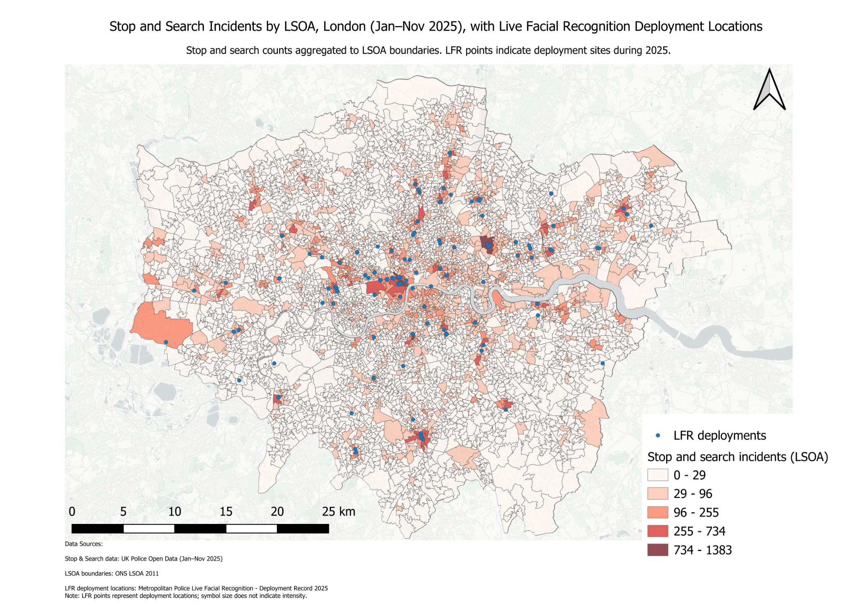

**Figure 1.** Stop and Search Incidents by LSOA, London (Jan–Nov 2025) with Live Facial Recognition deployment locations.

*Data sources: Home Office stop and search open data (2025); ONS LSOA boundaries (2011); Metropolitan Police Service live facial recognition deployment locations (2025). Source data published under OGL v3.0* and *OGL v2.0. Map created by author using QGIS.*

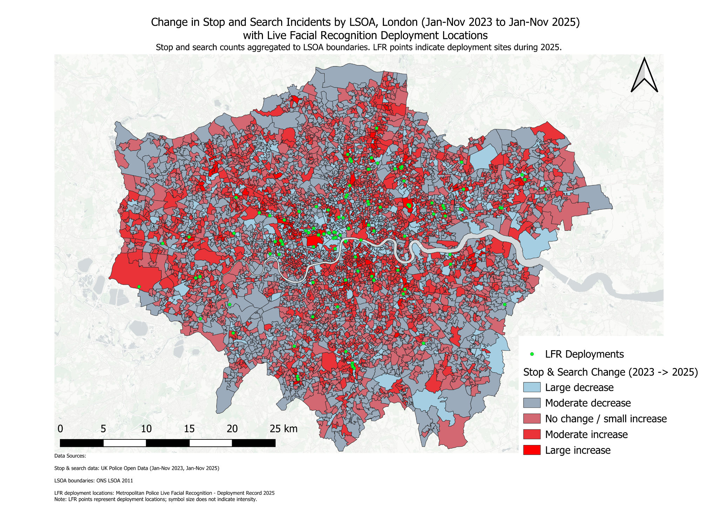

**Figure 2.** Change in Stop and Search Incidents by LSOA, London (2023–2025) with Live Facial Recognition deployment locations.

*Data sources: Home Office stop and search open data (2023, 2025); ONS LSOA boundaries (2011); Metropolitan Police Service live facial recognition deployment locations (2023–2025). Source data published under OGL v3.0* and *OGL v2.0. Map created by author using QGIS.*

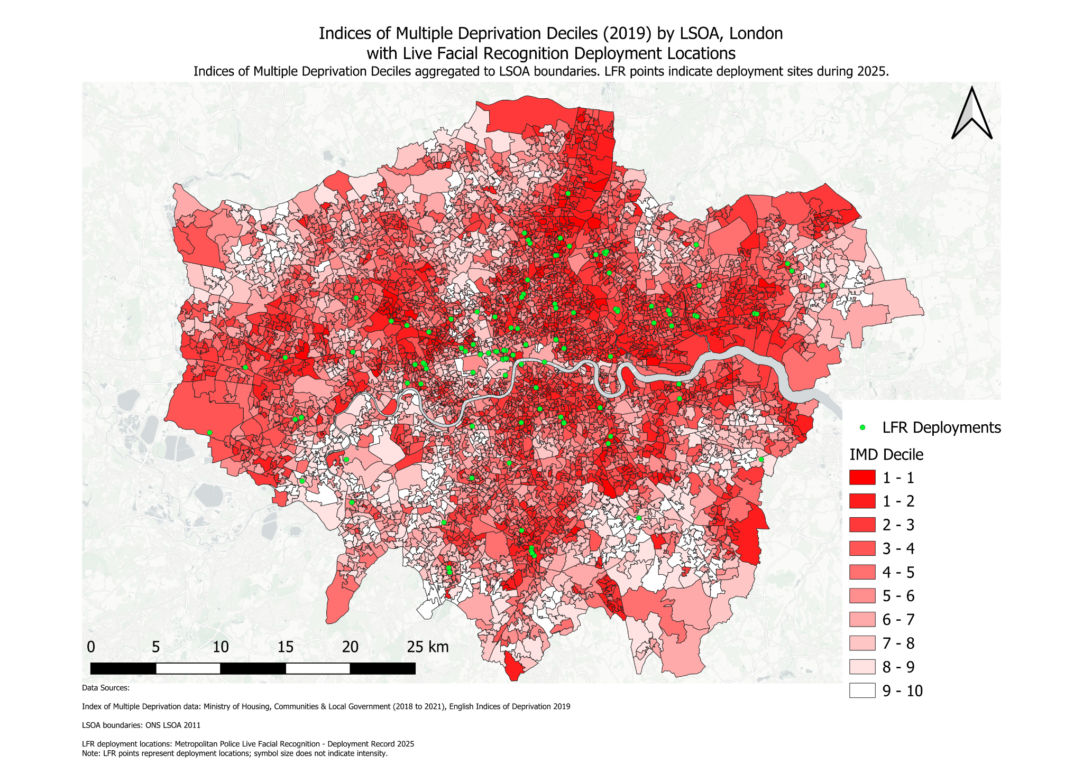

**Figure 3.** Index of Multiple Deprivation (IMD) by LSOA, London, with Live Facial Recognition deployment locations.

*Data sources: Ministry of Housing, Communities & Local Government (IMD 2019); ONS LSOA boundaries (2011); Metropolitan Police Service live facial recognition deployment locations (2023–2025). Source data published under OGL v3.0* and *OGL v2.0. Map created by author using QGIS.*

| **Measure** | **Result** |
| --- | --- |
| **Total number of LFR deployments analysed** | **230 deployments** |
| **Stop and search threshold defining the top 10% of LSOAs** | **More than 53.6 stop and search incidents** |
| **Number of LFR deployments in top 10% stop and search LSOAs** | **171 deployments** |
| **Percentage of all LFR deployments in top 10% stop and search LSOAs** | **74.35%** |
| **Stop and search threshold defining the top 20% of LSOAs** | **More than 32.0 stop and search incidents** |
| **Number of LFR deployments in top 20% stop and search LSOAs** | **194 deployments** |
| **Percentage of all LFR deployments in top 20% stop and search LSOAs** | **84.35%** |
| **Number of LFR deployments in LSOAs where stop and search increased (2023–2025)** | **126 deployments** |
| **Number of LFR deployments in LSOAs where stop and search did not change** | **3 deployments** |
| **Number of LFR deployments in LSOAs where stop and search decreased** | **101 deployments** |
| **Percentage of LFR deployments in areas with rising stop and search** | **54.78%** |
| **Percentage of LFR deployments in areas with no change in stop and search** | **1.30%** |
| **Percentage of LFR deployments in areas with falling stop and search** | **43.91%** |
| **Number of LSOAs in the most deprived decile (IMD)** | **107 LSOAs** |
| **Number of LSOAs in the three most deprived deciles (IMD)** | **1,606 LSOAs** |
| **Number of LFR deployments in the most deprived decile** | **13 deployments** |
| **Number of LFR deployments in the three most deprived deciles** | **145 deployments** |
| **Percentage of LFR deployments in the most deprived decile** | **5.65%** |
| **Percentage of LFR deployments in the three most deprived deciles** | **63.04%** |

**Table 1:** Summary statistics on the spatial relationship between Live Facial Recognition (LFR) deployment, stop and search activity, and area-level deprivation in London

## Interpretations

This section identifies sociological risks associated with the concentrated deployment of LFR in areas with high stop & search and deprivation levels.

Analysis of stop & search and LFR data for 2025 (Figure 1) shows that LFR deployments and stop & search incidents are mostly clustered in the same areas. This suggests that LFR is part of a cumulative policing strategy, where methods are layered rather than used in isolation. This interpretation aligns with Metropolitan Police data, which shows that LFR systems were primarily deployed to “crime hotspots” (areas that are already likely to attract the focus of police).[16]

The change-over-time analysis (Figure 2) indicates that LFR deployments are weighted towards areas that have seen an increase in stop & search. This reinforces the interpretation that LFR is layered on top of existing police measures.

There is a risk that layered policing of crime hotspots – particularly policing that involves LFR – leads to cumulative pressure being placed on communities in the area. This report argues that LFR delivers a surveillance burden at least similar to that of stop & search, given the scanning of every individual that comes into the Zone of Recognition.[17] There is a risk that the overall surveillance pressure on communities accumulates over time as new tactics are incorporated and repeatedly deployed.[18] This cumulative effect could place additional pressure on civil liberties. For example, a 2024 CETas report notes how heavy surveillance of a population could have a stifling effect on the rights of free assembly.[19]

Furthermore, communities that experienced the highest levels of LFR deployments in London also generally experienced higher levels of socio-economic deprivation (Figure 3). Concentrating LFR deployments in areas of higher deprivation creates risks specific to that deprivation context.

Scholarship by the Ada Lovelace Institute reveals that individuals in lower-income communities have a higher likelihood of being concerned about the use of facial recognition in policing than the general population.[20] Evidence in this report points towards more deprived groups experiencing the majority of LFR deployments. Given the inclusion of income data within the IMD calculation, a tentative position can be taken that LFR deployments are concentrated in areas that are more likely to be distrustful of the technology. Without fixing this issue, focused deployments in these areas risk further undermining trust.

Additionally, a recent article in the European Journal of Criminology cited the high burden of surveillance involved in stop & search as a “mechanism for reinforcing social inequalities.”[21] Given this report’s interpretation that the surveillance burden of LFR is at least similar to that of stop & search, this insight reveals the risk of further entrenching inequality by concentrating LFRs in deprived areas.

## Policy Implications & Conclusion

If implemented appropriately, LFR could benefit cohesion and trust by reducing the number of criminals on the streets. However, if implemented incorrectly, it risks further damaging relationships between communities and their police. The purpose of this report is to reveal where LFR has been deployed thus far in London and to provide insights about the risks associated with deployment location patterns.

Alongside the sociological issues explored in the previous section, this report’s findings may also have implications for policing policy. This report suggests that the concentration of LFR deployments in deprived areas with high stop & search activity may represent disproportionate policing.

Proportionality is a key requirement for LFR deployments, as it is for all policing methods.[22] This report understands disproportionality as a condition where a “certain group of people is affected by police action in a way that is substantially different from people not of that group.”[23] This report argues that the experiences of deprived groups in LSOAs with high stop & search activity may be substantially different to groups in other LSOAs when it comes to LFR deployments.

Essentially, communities in deprived areas are experiencing a disproportionate burden of LFR deployment compared with other communities. Many LSOAs with high stop & search and deprivation levels experienced multiple LFR deployments across a single year. By contrast, many LSOAs with comparatively low stop & search and deprivation levels experienced no LFR deployments in 2025.

Furthermore, the effects of multiple LFR deployments in one area can be conceptualised as cumulative. LFR deployments are also layered on top of pre-existing stop & search methods, which heighten the overall surveillance burden. This higher-than-normal burden risks limiting social freedoms and entrenching inequality in deprived areas. This risks further reducing the trust that lower-income communities place in the technology.

In conclusion, this report argues that, given current practice, LFR deployments by the Metropolitan Police could be considered disproportionate. It also argues that the concentration of deployments in areas of high deprivation might further consolidate inequality.

In line with public health perspectives on crime,[24] these concentrated deployments risk a negative feedback loop, where LFR reinforces the conditions that created a “crime hotspot” in the first place.

## 

## 

## 

## Bibliography

Agnew-Pauley, Winifred, Caitlin Elizabeth Hughes, and Alex Stevens. ‘A Realist Review on the Police Use of Stop and Search Powers’. *European Journal of Criminology* 22, no. 3 (2025): 346–74.<https://doi.org/10.1177/14773708241290593>.

Big Brother Watch Team. ‘Met Police Face Major Legal Challenge over Use of Live Facial Recognition Technology’. 22 July 2025.<https://bigbrotherwatch.org.uk/press-releases/met-police-face-major-legal-challenge-over-use-of-live-facial-recognition-technology/>.

Birtwistle, Micheal, and Nuala Polo. *An Eye on the Future*. Ada Lovelace Institute, 2025.<https://www.adalovelaceinstitute.org/policy-briefing/an-eye-on-the-future/>.

Data.Police.UK. ‘Stop and Search Data Metropolitan Police’. CSV. November 2023. [Data published under the Open Government Licence v3.0. https://data.police.uk/data/](https://data.police.uk/data/).

Data.Police.UK. ‘Stop and Search Data Metropolitan Police’. CSV. November 2025. [Data published under the Open Government Licence v3.0. https://data.police.uk/data/](https://data.police.uk/data/).

Dodd, Vikram. ‘London’s Murder Rate Drops to Lowest in More than a Decade’. *The Guardian*, 12 January 2026.<https://www.theguardian.com/uk-news/2026/jan/12/london-homicide-rate-drops-to-lowest-in-more-than-a-decade>.

Dodd, Vikram. ‘Stop and Search Study in England and Wales “Casts Doubt” on Effectiveness’. *The Guardian*, 21 August 2024.<https://www.theguardian.com/law/article/2024/aug/21/stop-and-search-study-in-england-and-wales-casts-doubt-on-effectiveness>.

Edwards, Charlotte. ‘Human Rights Regulator Criticises Met’s Use of Facial Recognition Cameras’. *BBC News*, 20 August 2025.<https://www.bbc.co.uk/news/articles/c1kzgx4v2pko>.

GPS.Coordinates.net. *GPS Coordinates*. Released 2026.<https://www.gps-coordinates.net/>.

His Majesty’s Inspectorate of Constabulary and Fire & Rescue Services. *Disproportionate Use of Police Powers – A Spotlight on Stop and Search and the Use of Force*. 2021.<https://hmicfrs.justiceinspectorates.gov.uk/publications/disproportionate-use-of-police-powers-a-spotlight-on-stop-and-search-and-the-use-of-force/>.

Home Office. *Consultation on a New Legal Framework for Law Enforcement Use of Biometrics, Facial Recognition and Similar Technologies (Accessible)*. 2026.<https://www.gov.uk/government/consultations/legal-framework-for-using-facial-recognition-in-law-enforcement/consultation-on-a-new-legal-framework-for-law-enforcement-use-of-biometrics-facial-recognition-and-similar-technologies-accessible>.

Home Office. *Guidance - Police Use of Facial Recognition: Factsheet*. 2025.<https://www.gov.uk/government/publications/police-use-of-facial-recognition/police-use-of-facial-recognition-factsheet>.

Jessup, Sonja. ‘“Facial Recognition Tech Mistook Me for Wanted Man”’. *BBC News*, 6 August 2025.<https://www.bbc.co.uk/news/articles/cqxg8v74d8jo>.

Jessup, Sonja. ‘London Homicides at 11-Year Low, Met Police Says’. *BBC News*, 12 January 2026.<https://www.bbc.co.uk/news/articles/cwy8gpvdd1go>.

London Datastore, Greater London Authority. ‘Previous LSOA Boundaries 2001-2011’. CSV. 1 October 2014. Data published under the Open Government Licence v2.0. <https://data.london.gov.uk/dataset/lsoa-atlas-2n8zy/>.

Metropolitan Police. *Data Protection Appropriate Policy Document* (11 September 2025). Accessed 11 January 2026.<https://www.met.police.uk/SysSiteAssets/media/downloads/force-content/met/advice/lfr/new/mps-lfr-apd.pdf>.

Metropolitan Police. ‘Live Facial Recognition - Deployment Record 2025’ PDF. https://www.met.police.uk/police-forces/metropolitan-police/areas/about-us/about-the-met/facial-recognition-technology/. Accessed 9 January 2026. [Data published under the Open Government Licence v3.0. https://www.met.police.uk/SysSiteAssets/media/downloads/force-content/met/advice/lfr/deployment-records/live-facial-recognition---deployment-record-2025-to-date.pdf](https://www.met.police.uk/SysSiteAssets/media/downloads/force-content/met/advice/lfr/deployment-records/live-facial-recognition---deployment-record-2025-to-date.pdf).

Metropolitan Police. *MPS Overt LFR Policy Document*. 2025.<https://www.met.police.uk/SysSiteAssets/media/downloads/force-content/met/advice/lfr/policy-documents/lfr-policy-document2.pdf>.

Ministry of Housing, Communities & Local Government (2018 to 2021). ‘English Indices of Deprivation 2019’. XLSX. 26 September 2019. [Data published under the Open Government Licence v3.0. https://www.gov.uk/government/statistics/english-indices-of-deprivation-2019](https://www.gov.uk/government/statistics/english-indices-of-deprivation-2019).

Modhvadia, Roshni, Tvesha Sippy, Octavia Field Reid, and Helen Margetts. *How Do People Feel About AI?* Ada Lovelace Institute and The Alan Turing Institute, 2025.<https://attitudestoai.uk/>.

Oxley, Gregg, Allwell Awazuruike, Maria Lalic, Harriet Samuel, and William Downs. *Police Use of Live Facial Recognition Technology*. House of Commons Library, 2024.<https://researchbriefings.files.parliament.uk/documents/CDP-2024-0144/CDP-2024-0144.pdf>.

Stockwell, Sam, Meghan Hughes, Carolyn Ashurst, and Nóra NíLoideáin. *The Future of Biometric Technology for Policing and Law Enforcement: Informing UK Regulation*. CETaS Research Reports, 2024.

Violence Reduction Unit. ‘A Public Health Approach to Reducing Violence’. Accessed 20 January 2026.<https://www.london.gov.uk/programmes-strategies/violence-reduction-unit-vru/public-health-approach-reducing-violence>.

1. Home Office, *Consultation on a New Legal Framework for Law Enforcement Use of Biometrics, Facial Recognition and Similar Technologies (Accessible)* (2026),<https://www.gov.uk/government/consultations/legal-framework-for-using-facial-recognition-in-law-enforcement/consultation-on-a-new-legal-framework-for-law-enforcement-use-of-biometrics-facial-recognition-and-similar-technologies-accessible>.
2. His Majesty’s Inspectorate of Constabulary and Fire & Rescue Services, *Disproportionate Use of Police Powers – A Spotlight on Stop and Search and the Use of Force* (2021),<https://hmicfrs.justiceinspectorates.gov.uk/publications/disproportionate-use-of-police-powers-a-spotlight-on-stop-and-search-and-the-use-of-force/>.
3. Gregg Oxley et al., Police Use of Live Facial Recognition Technology (House of Commons Library, 2024), <https://researchbriefings.files.parliament.uk/documents/CDP-2024-0144/CDP-2024-0144.pdf>, p. 2.
4. Metropolitan Police, MPS Overt LFR Policy Document (2025), <https://www.met.police.uk/SysSiteAssets/media/downloads/force-content/met/advice/lfr/policy-documents/lfr-policy-document2.pdf>, p. 5.
5. Oxley, Police Use (2024), p. 3; Home Office, Guidance - Police Use of Facial Recognition: Factsheet (2025), <https://www.gov.uk/government/publications/police-use-of-facial-recognition/police-use-of-facial-recognition-factsheet>
6. Charlotte Edwards, ‘Human Rights Regulator Criticises Met’s Use of Facial Recognition Cameras’, BBC News, 20 August 2025, <https://www.bbc.co.uk/news/articles/c1kzgx4v2pko>
7. Sonja Jessup, ‘London Homicides at 11-Year Low, Met Police Says’, BBC News, 12 January 2026, <https://www.bbc.co.uk/news/articles/cwy8gpvdd1go>
8. Vikram Dodd, ‘London’s Murder Rate Drops to Lowest in More than a Decade’, The Guardian, 12 January 2026, <https://www.theguardian.com/uk-news/2026/jan/12/london-homicide-rate-drops-to-lowest-in-more-than-a-decade>
9. Sonja Jessup, ‘“Facial Recognition Tech Mistook Me for Wanted Man”’, BBC News, 6 August 2025, <https://www.bbc.co.uk/news/articles/cqxg8v74d8jo>
10. Roshni Modhvadia et al., How Do People Feel About AI? (Ada Lovelace Institute and The Alan Turing Institute, 2025), <https://attitudestoai.uk/>, p. 28.
11. Metropolitan Police, ‘Live Facial Recognition - Deployment Record 2025’, PDF, accessed 9 January 2026, <https://www.met.police.uk/SysSiteAssets/media/downloads/force-content/met/advice/lfr/deployment-records/live-facial-recognition---deployment-record-2025-to-date.pdf>.
12. Data.Police.UK, ‘Stop and Search Data Metropolitan Police’, CSV, January-November 2023 + 2025, <https://data.police.uk/data/>
13. Ministry of Housing, Communities & Local Government (2018 to 2021), ‘English Indices of Deprivation 2019’, XLSX, 26 September 2019, <https://www.gov.uk/government/statistics/english-indices-of-deprivation-2019>.
14. London Datastore, Greater London Authority, ‘Previous LSOA Boundaries 2001-2011’, CSV, 1 October 2014,<https://data.london.gov.uk/dataset/lsoa-atlas-2n8zy/>.
15. GPS.Coordinates.net, *GPS Coordinates*, Accessewered 10 January 2026,<https://www.gps-coordinates.net/>.
16. Metropolitan Police, ‘Deployment Record 2025’.
17. Metropolitan Police, LFR Policy, p. 5.
18. Micheal Birtwistle and Nuala Polo, *An Eye on the Future* (Ada Lovelace Institute, 2025),<https://www.adalovelaceinstitute.org/policy-briefing/an-eye-on-the-future/>, p. 40.
19. Sam Stockwell et al., *The Future of Biometric Technology for Policing and Law Enforcement: Informing UK Regulation* (CETaS Research Reports, 2024), p. 14
20. Modhvadia et al, *Feel About AI?*, p. 28
21. Winifred Agnew-Pauley et al., ‘A Realist Review on the Police Use of Stop and Search Powers’, European Journal of Criminology 22, no. 3 (2025): 346–74,, p. 357. <https://doi.org/10.1177/14773708241290593>.
22. Home Office, *Consultation on a New Legal Framework for Law Enforcement Use of Biometrics, Facial Recognition and Similar Technologies (Accessible)* (2025),<https://www.gov.uk/government/consultations/legal-framework-for-using-facial-recognition-in-law-enforcement/consultation-on-a-new-legal-framework-for-law-enforcement-use-of-biometrics-facial-recognition-and-similar-technologies-accessible>.
23. His Majesty’s, *Disproportionate,* p. 8.
24. Violence Reduction Unit, ‘A Public Health Approach to Reducing Violence’, accessed 20 January 2026,<https://www.london.gov.uk/programmes-strategies/violence-reduction-unit-vru/public-health-approach-reducing-violence>.